TOA Final Exam Paper
CLO 3: Design of automata, RE and CFG
Question 1: [4+4+14+6+5 Marks] [80 mins]
- Find the reverse and complement of FA 1 and FA 2. The resultant machines must be DFAs.

FA 1: FA 2:
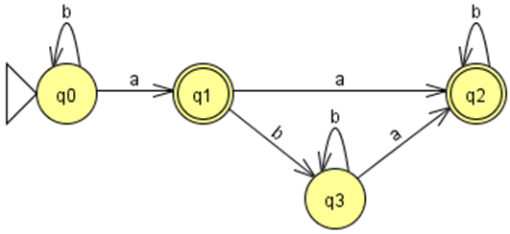
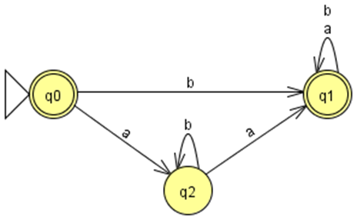

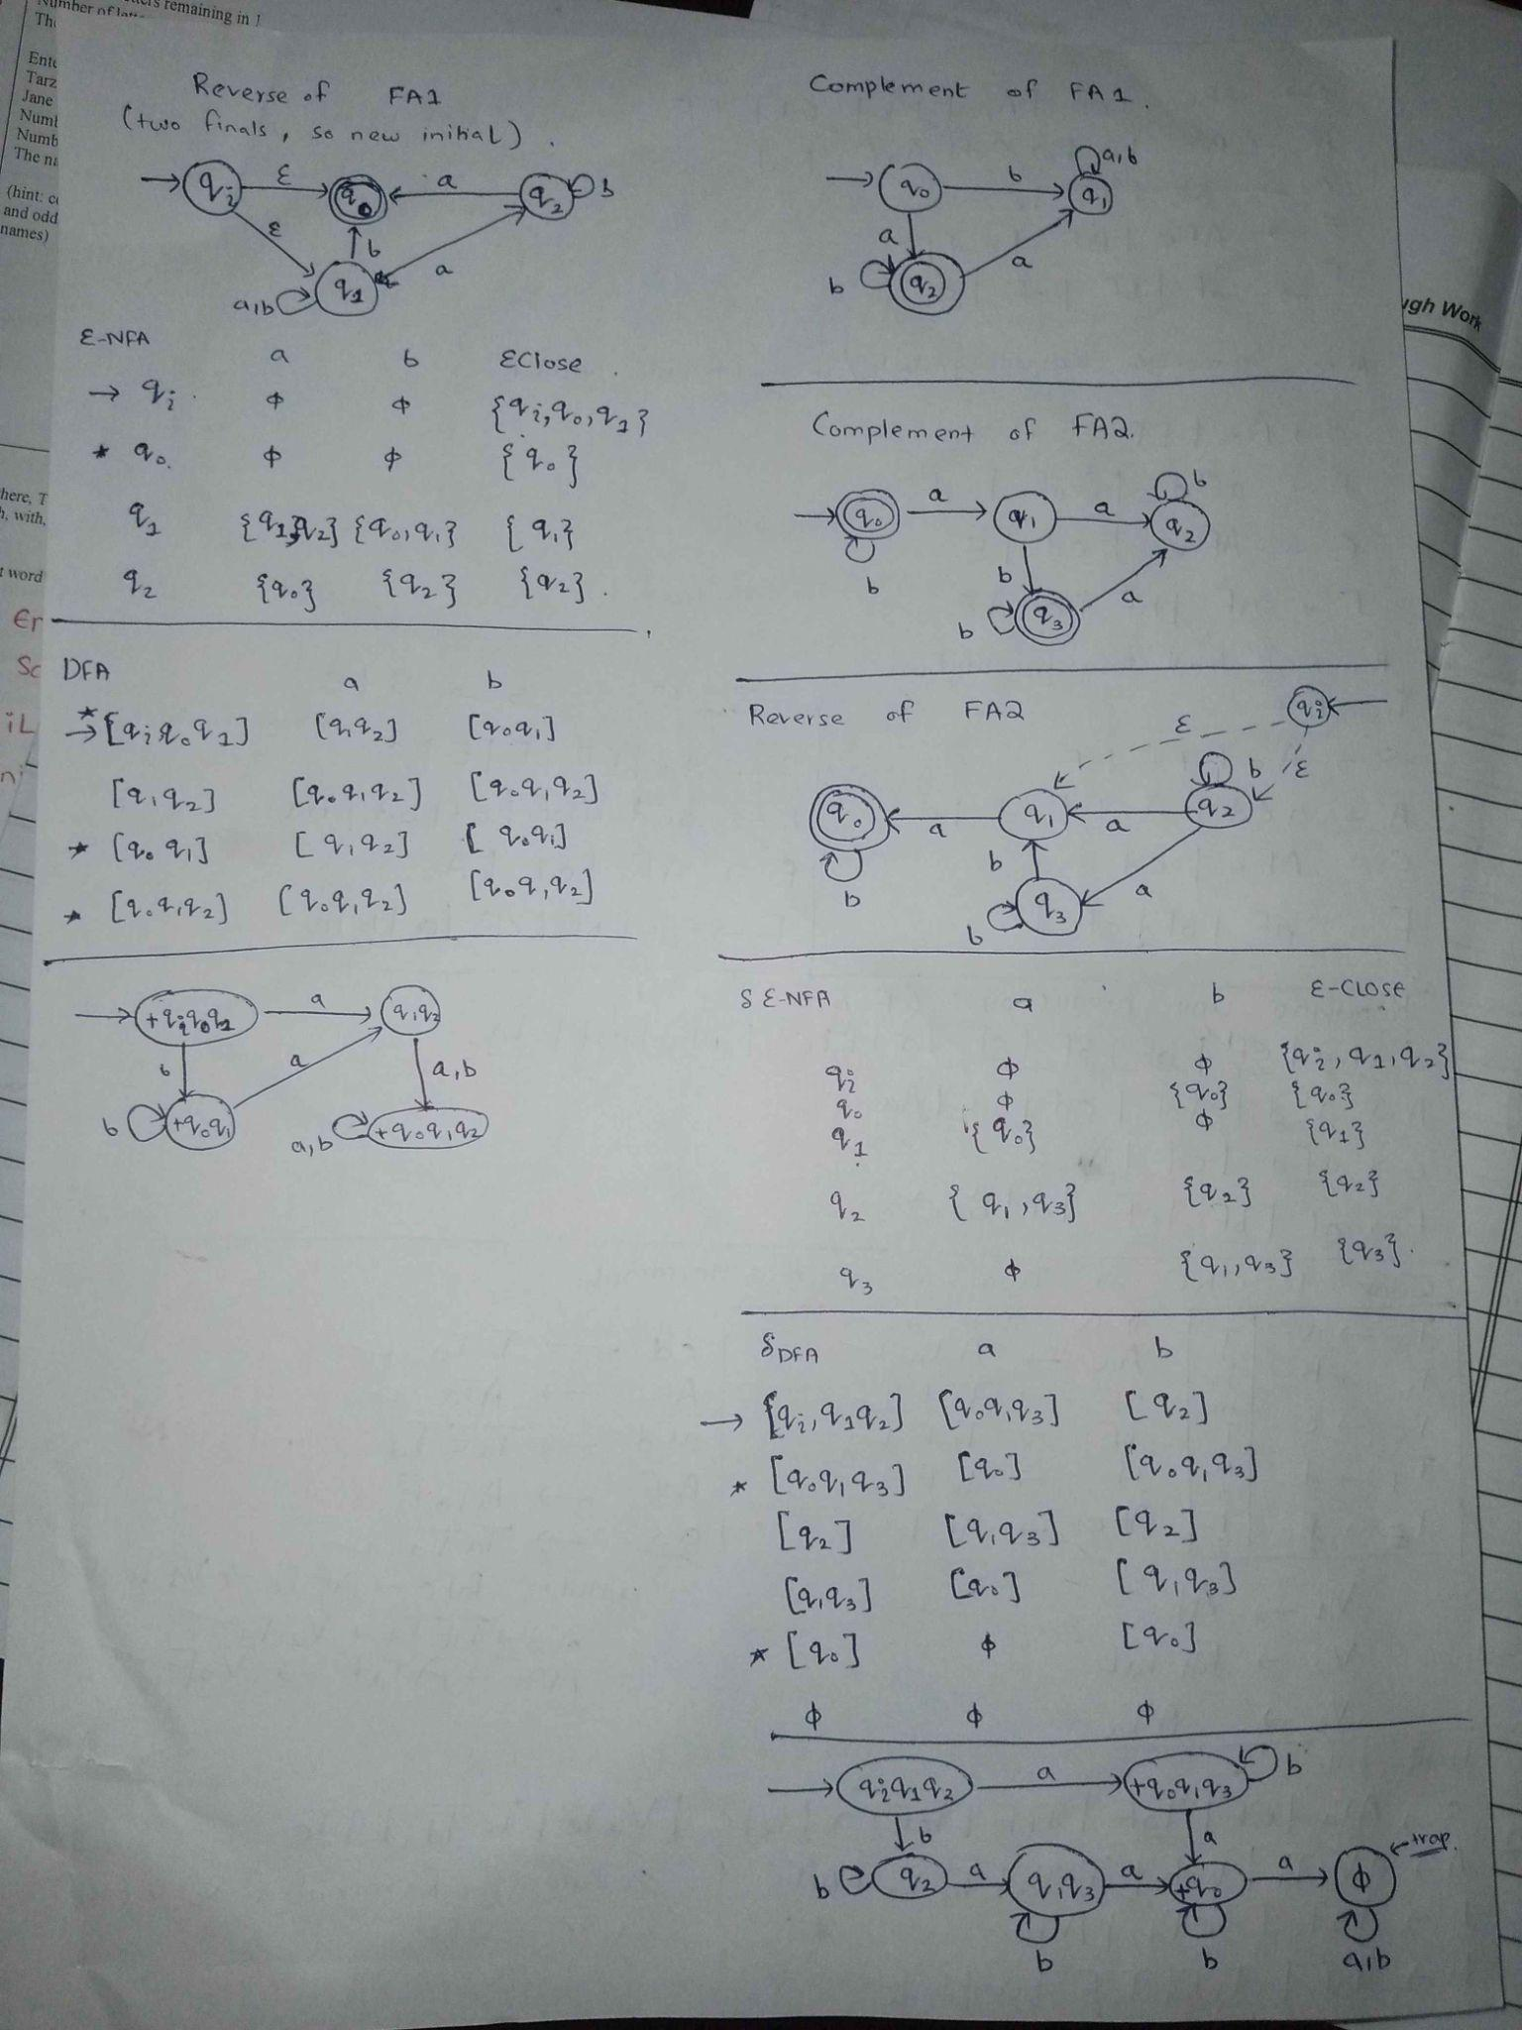

- State Elimination
Convert the following FA to RE using state elimination method:
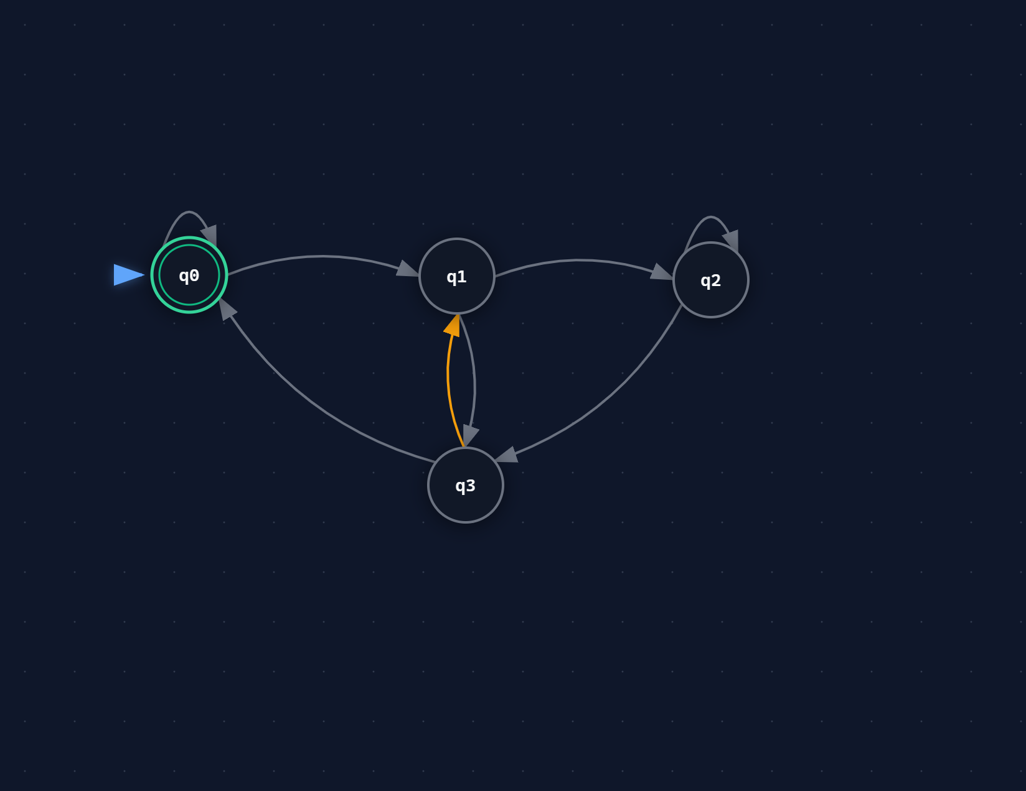
Transitions: qo–1—qo, qo–0–q1, q1–1—q2, q2–0–q2, q2–1–q3, q3–0–qo, q1–0–q3 and q3–1–q1.

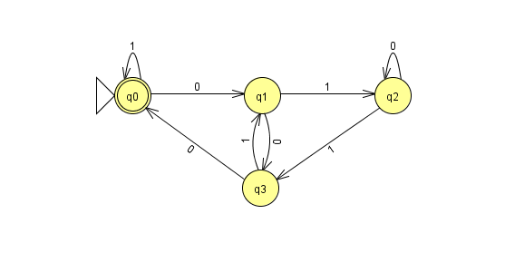
PLEASE NOTE THE SOLUTION I HAVE SHARED HAS FIRST ONE OF Q 2C
AND BELOW IT IS SOLUTION ON Q 1B.
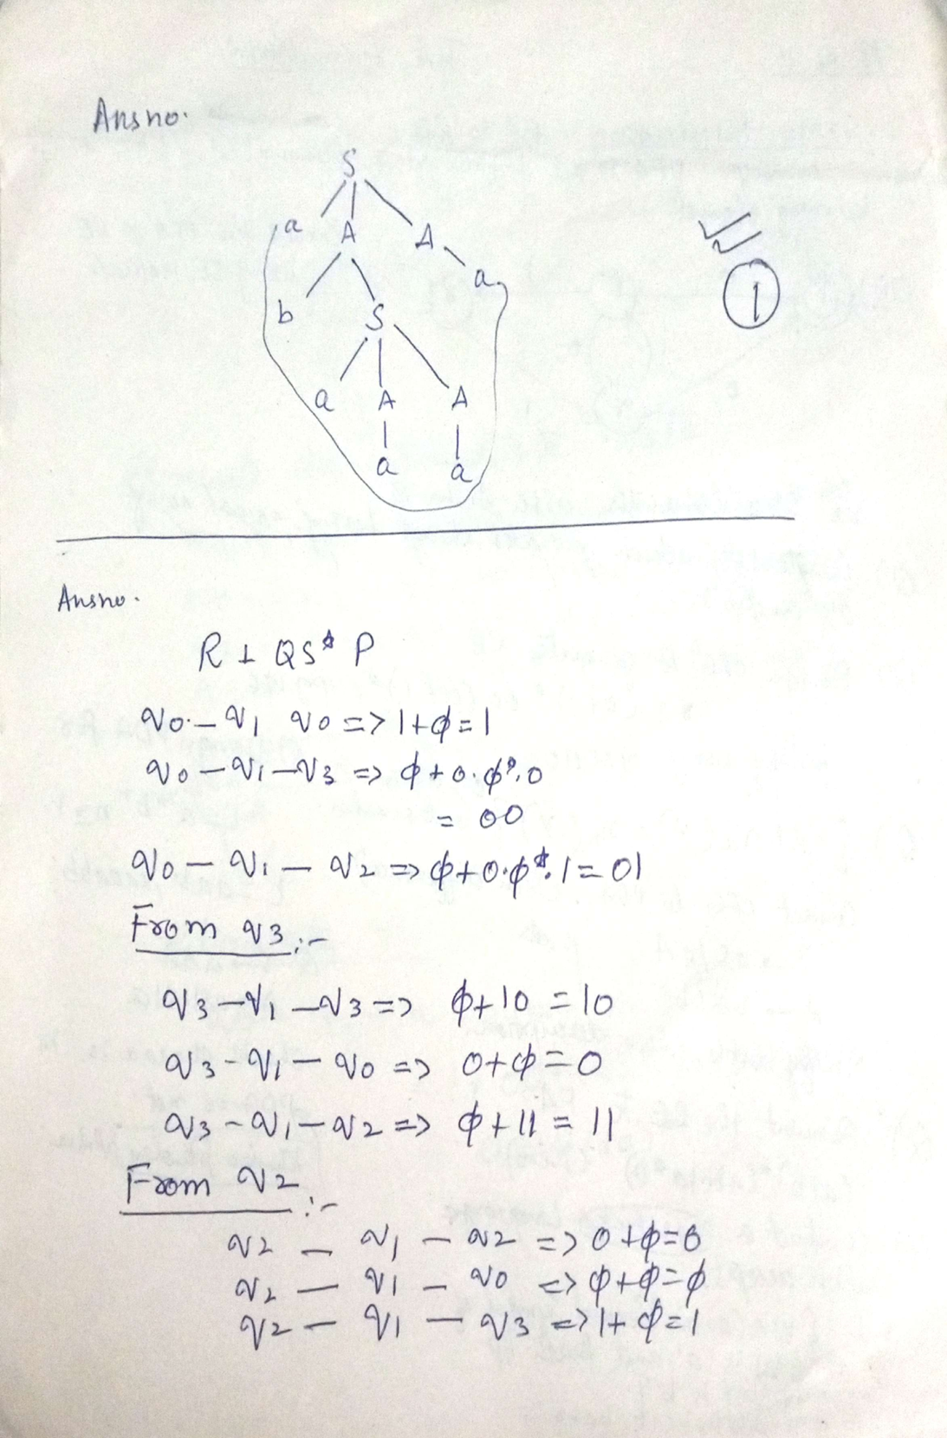
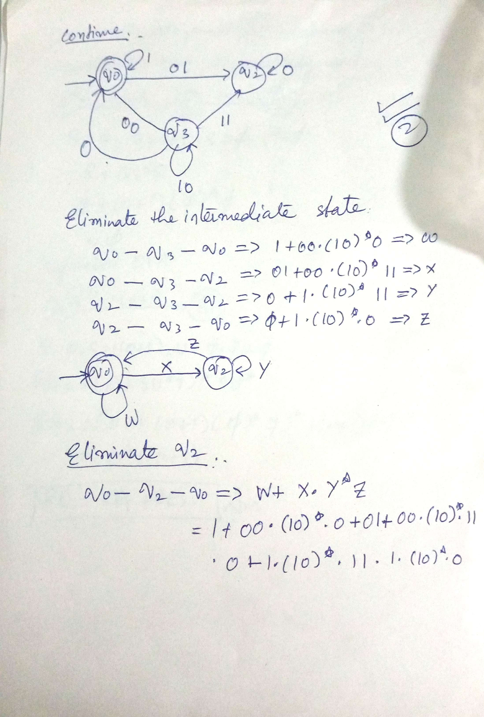
- Write the regular expression, regular grammar, and construct the DFA for the following languages(L1,L2,L3), Σ = {a,b}:
  - L1 = { w | w does not contain baba }
Sol: E is epsilon.
( a + bb*aa + bb*ab(bb*ab)*bb*aa ) ( bb*ab(bb*ab)*(E + bb*a(E + bb*)) + E +bb* + bb*a(E+bb*) )
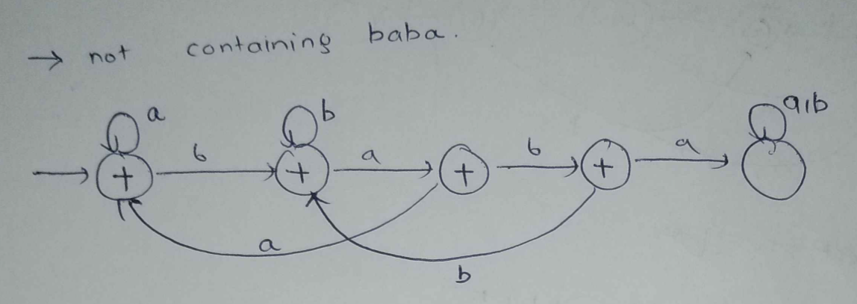
RG:
q0 -> aq0 | bq1 | E
q1 -> aq2 | bq1 | E
q2 -> aq0 |bq3 | E
q3 -> bq1 | E
  - L2 = { w | w is any string except ‘a’ and ‘b’ }
Sol: E is epsilon.
E + (a+b)(a+b)(a+b)*
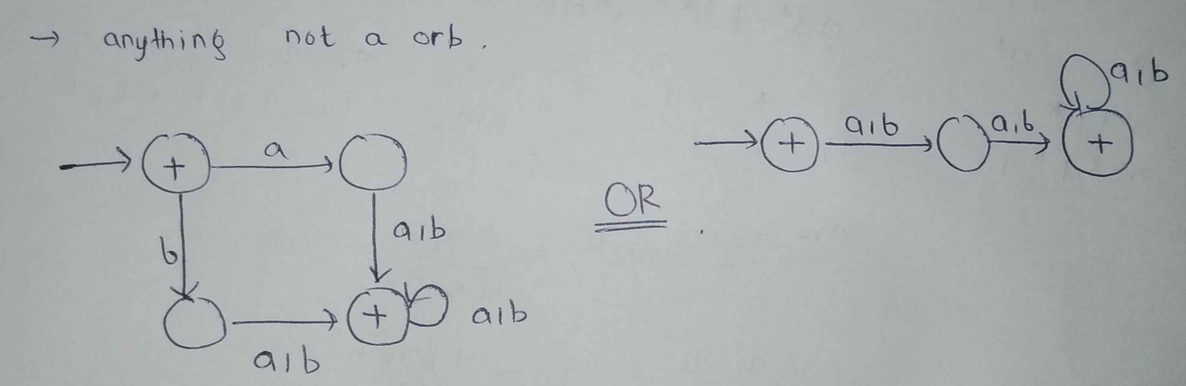
RG:
q0 -> aq1 | bq1 | E
q1 -> aq2 | bq2
q2 -> aq2 | bq2 | E

  - L3 = { w | second symbol of w is ‘a’ and fourth input Symbol is ‘b’}
E.g, aaab, baab, babb,.......

  - Convert the following RE to FA:
(a|b)* (abb|a*b)
- Perform simplification for the following grammar, and then convert it into CNF.
S → ABC | CD | Aa | Bb | Dd | EF
A → AB | BC | aEd | AaF | cd
C → AB | Cc | ɛ
E → Afe | BF | cd | ɛ
F → aF | bF | cF | ɛ

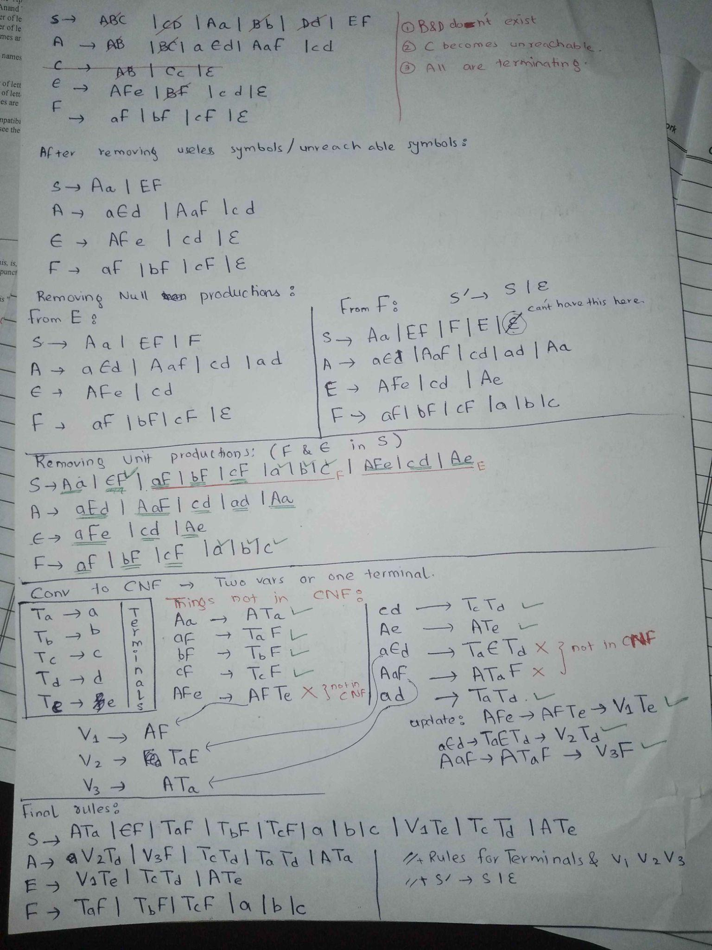

- Grammar to PDA
Given:
S—--> aAA
A—--> aS|bS|a
Design PDA for the given grammar and check the Confirmation of string: abaaaa.

SOL:

CLO 5: Define Turing machines, PDA machines performing simple tasks.
Question 2: PDA, CFG [10+5+12 Marks] [40 mins]
Design PDA and CFG of given lang uages
- L(G1) ={a^{i} b^{j} c^{m} d^{n} | i=3j || m=n+4 where j>=1 , n>=1}
Solution
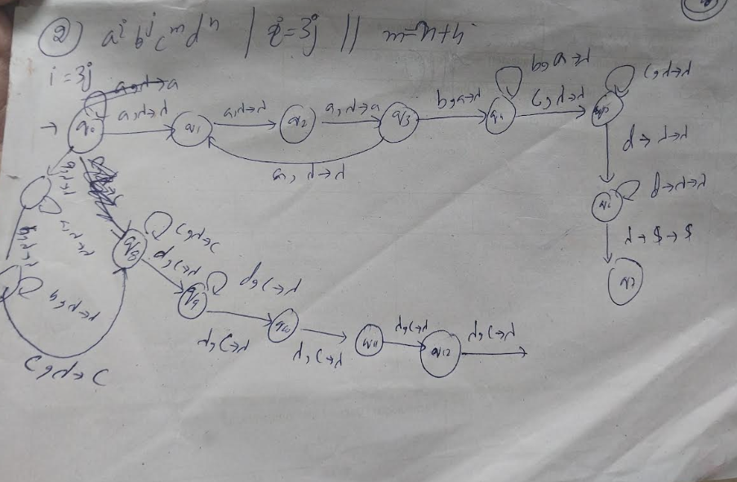

- A university compiler checks the correctness of a program block based on the following rules:
The program starts with some number of function calls represented by the symbol ‘f’.
Each function call must be matched with a return statement represented by symbol ‘r’.
After all function calls are completed, the program may contain loop blocks represented by symbol ‘l’.
For every loop block l, there must be exactly two exit statements represented by symbol ‘e’.
Solution
f^n r^n l^m e^2m

3. L(G3) ={a^{i} b^{j} c^{2I+3J+4}| where i>=1, j>=1}
Solution
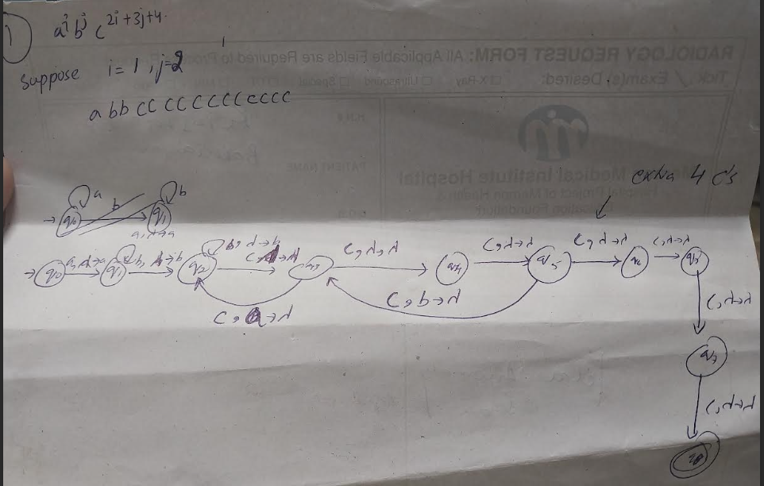
- Using your PDA design, write the sequence of instantaneous descriptions (IDs) for the input string:
w=abbcccccccccccc
Note: you have to design PDA From scratch do not convert Grammar into PDA
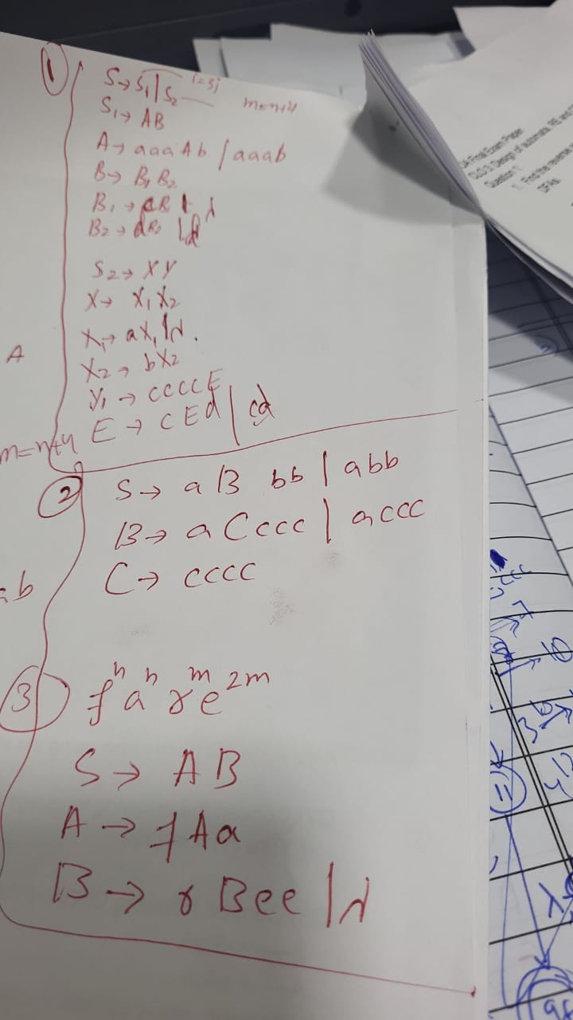

CLO 5: Define Turing machines, PDA machines performing simple tasks.
Question 3: Turing Machine Design [10+6+24 Marks] [60 mins]
Design Turing Machines (TM) for the following tasks. Show your state transitions, and sample computations for each part.
(a) Language Acceptance (10 marks)
Language:
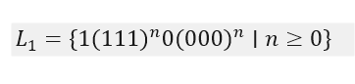
Task:
- Design a TM that accepts all strings in .
- Provide a sample computation for 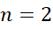.

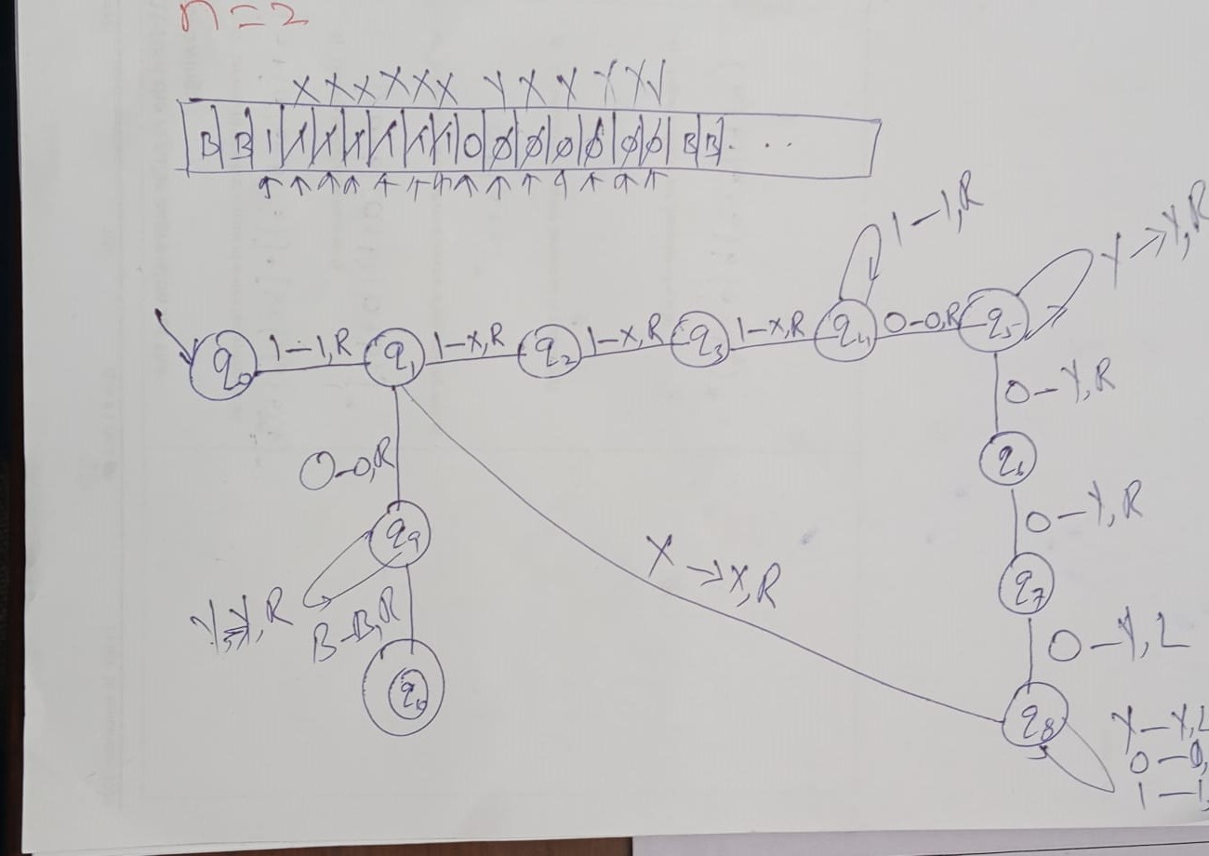

(b) Language Acceptance (6 marks)
Language:
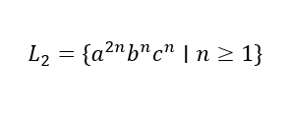
Task:
- Design a TM that accepts all strings in L2 .
- Provide a sample computation for n=2.

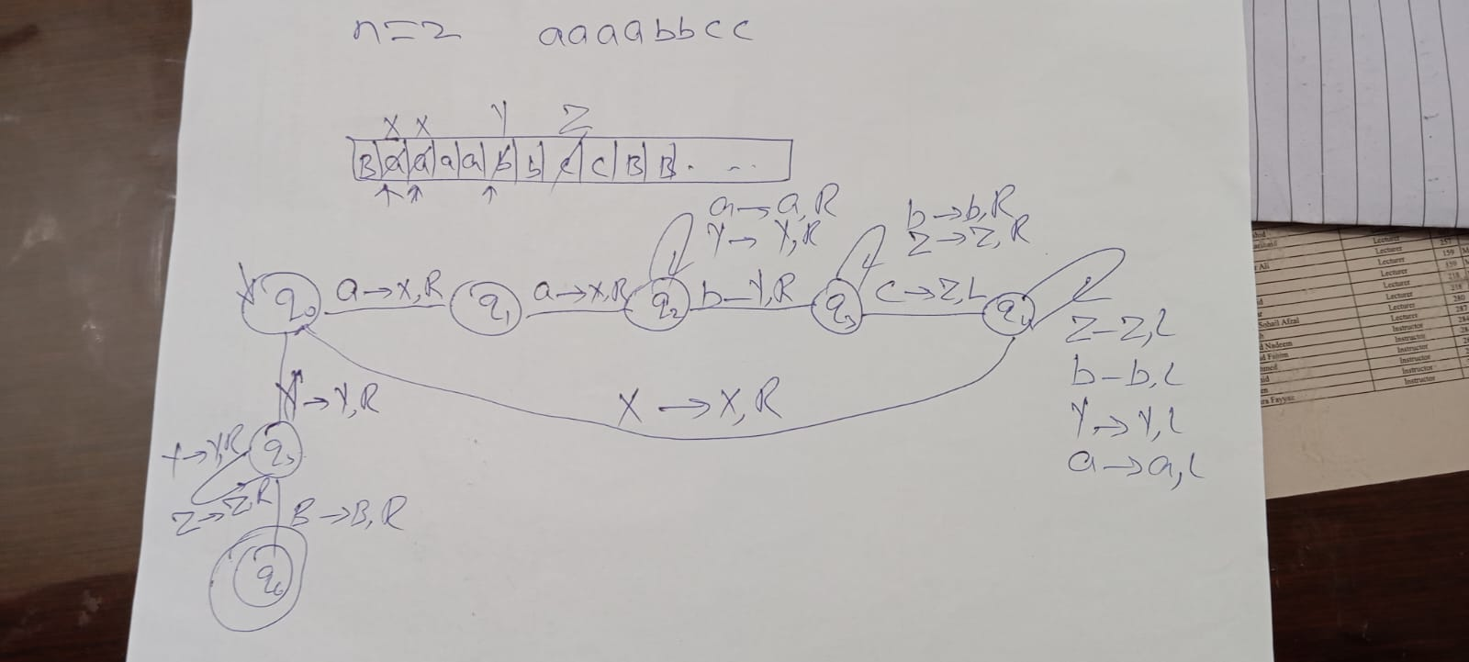

(c) Design a single-tape deterministic Turing Machine (TM) that computes the function
defined as follows: (24 marks)
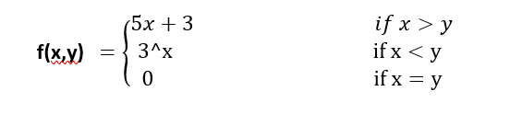
Sample Executions:
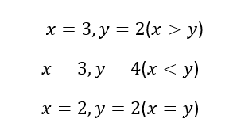

Solution if x>y 5x+3 q16 not include
Solution if x=y then q0,q1,q2,q3 and q16 are include q17 final B—>B,R

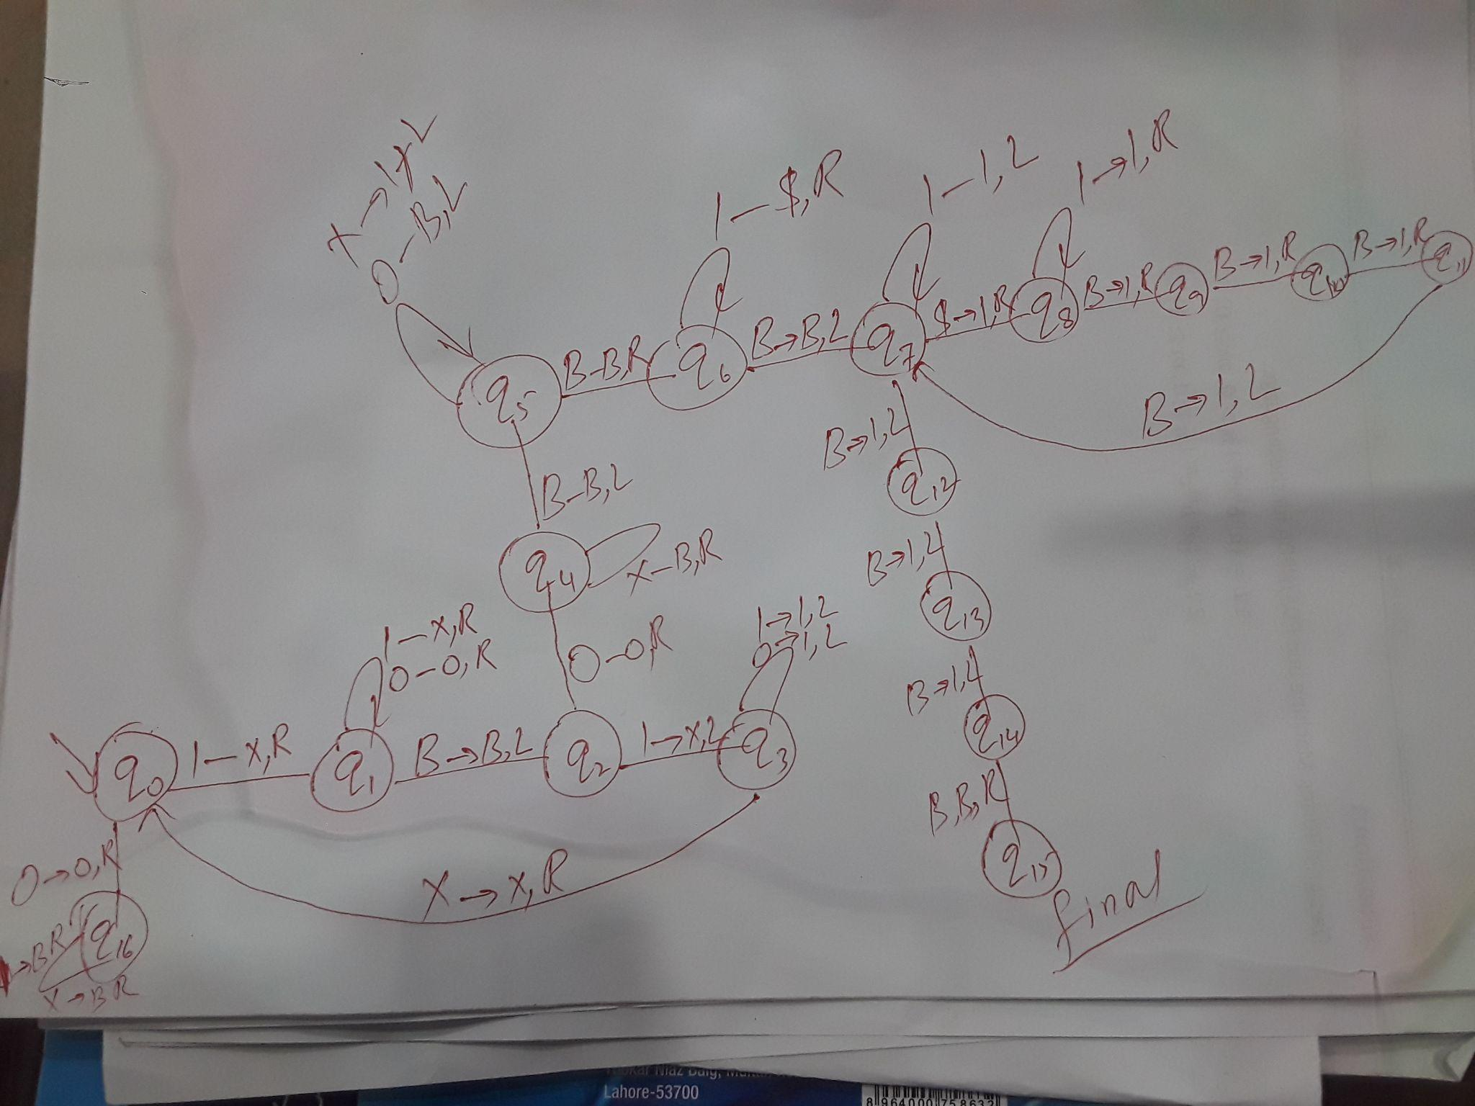

If x<y
Compare part not connected in the image only 3^x
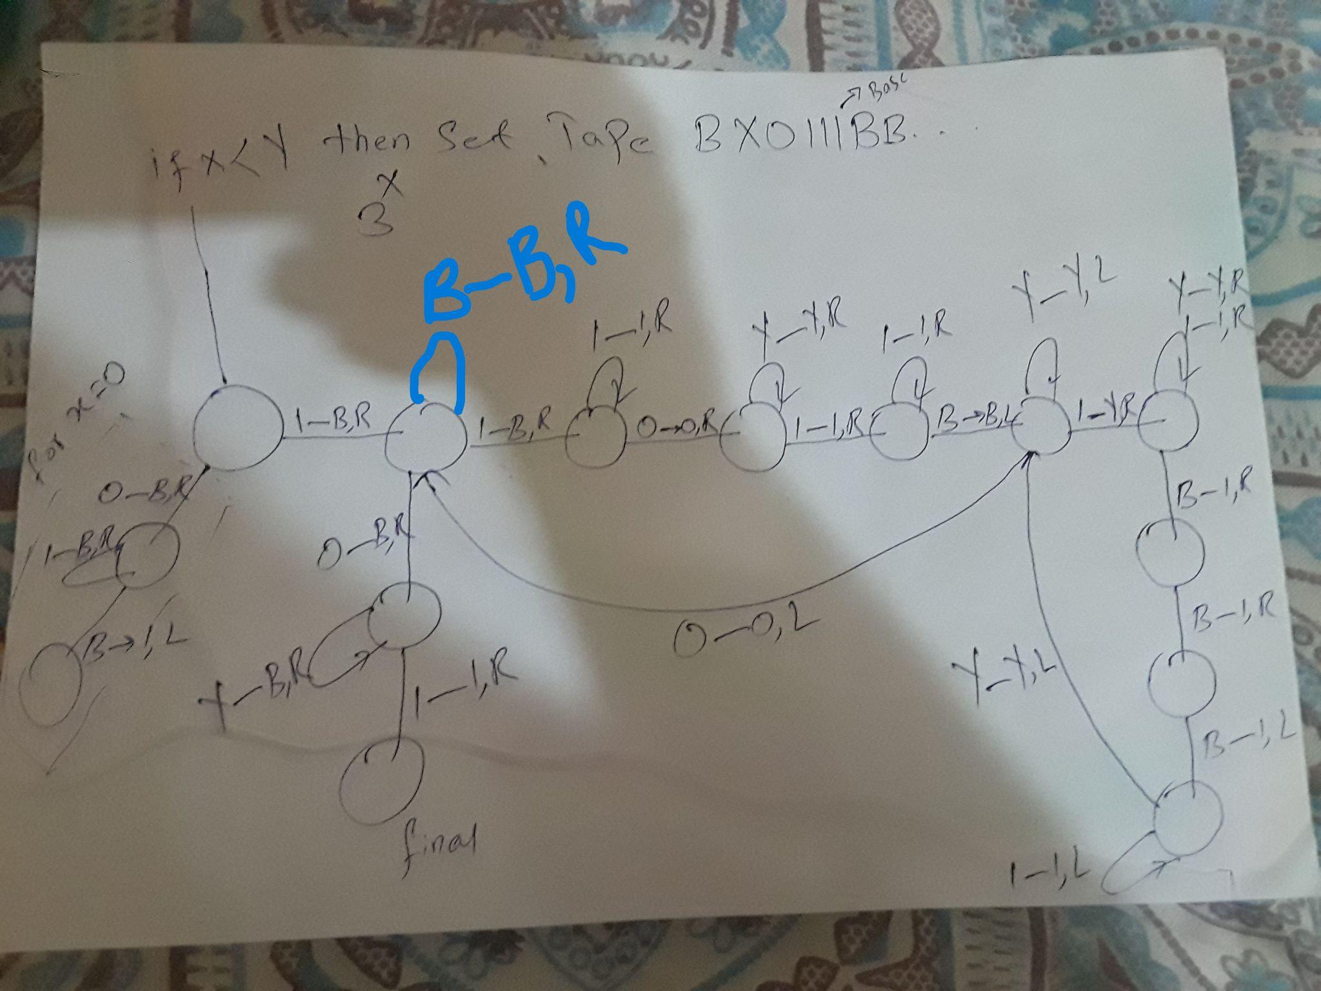

Kashan:
Q1) Design CFG to generate RE:
r= (0+1}^*00 (0+1)^*
Also show the justification using the string: 0100110.

Q2) Convert the following language to CFG:
{ Y| na (Y) = nb (Y) }

Q3) Convert following CFG to PDA:
S—-->aS|aA
A—--> bA|b
Verify aabb, show complete description.

Q5)
Q7)

